**SUGGESTION ANSWER SCHEME**

**COMPILATION PAST YEAR UPS SEMESTER 1**

**ENGINEERING CHEMISTRY**

**TK015 2012/2013**

|  |  |  |
| --- | --- | --- |
| 1 | a) | **TABLE 1** shows the particles of 86Rb2+ and 80Br- ions. Identify the values of ***A***, ***B*** and ***C*.** |

**TABLE 1**

|  |  |  |  |
| --- | --- | --- | --- |
| **Symbol** | **No. of protons** | **No. of electrons** | **No. of neutrons** |
| 86Rb2+ | ***A*** | 35 | ***B*** |
| 80Br- | 33 | ***C*** | 47 |

|  |  |  |
| --- | --- | --- |
|  |  | ***A = 37***  ***B = 49***  ***C = 34*** |

[3 marks]

|  |  |  |
| --- | --- | --- |
|  | b) | An aqueous solution containing 15 % methanol, CH3OH by mass has a density of 0.790 g mL-1. Calculate   1. the molarity of the solution.   ***15 % methanol ≡ 15 g CH3OH in 100 g of solution*** |

|  |  |  |
| --- | --- | --- |
|  |  | 1. its molality. 2. the volume of the solution that contains 0.10 mol of methanol.   [7 marks] |
|  |  |  |
| 2 | a) | A sample of iron ore was dissolved in an acidified K2Cr2O7 solution. All the Fe2+ ions were oxidized to Fe3+ ions, while the Cr2O72-  ions were reduced to Cr3+ ions.   1. What is the IUPAC name of Cr2O72- ion and the oxidation number of Cr in the ion?   ***Dichromate ion***  ***Oxidation no. = +6***   1. Write a balanced redox equation for this reaction.   ***Oxidation: Fe2+ → Fe3+***  ***Reduction: Cr2O72– → Cr3+***  ***Balance other than O & H***  ***Oxidation: Fe2+ → Fe3+***  ***Reduction: Cr2O72– → 2Cr3+***  ***Balance O by adding H2O***  ***Oxidation: Fe2+ → Fe3+***  ***Reduction: Cr2O72– → 2Cr3+ + 7H2O***  ***Balance H by adding H+***  ***Oxidation: Fe2+ → Fe3+***  ***Reduction: Cr2O72– + 14H+ → 2Cr3+ + 7H2O***  ***Balance charge***  ***Oxidation: Fe2+ → Fe3+ + e***  ***Reduction: Cr2O72– + 14H+ + 6e → 2Cr3+ + 7H2O***  ***Balance equation***  ***Oxidation: 6Fe2+ → 6Fe3+ + 6 e***  ***Reduction: Cr2O72- + 14H+ + 6e → 2Cr3+ + 7H2O***  ***Combine equation & Calculate the total charge***  ***6Fe2+ + Cr2O72– + 14H+ → 6Fe3+ + 2Cr3+ + 7H2O***  [5 marks] |
|  |  |  |
|  | b) | A sample of 4.33 x 103 g of iron (III) oxide, Fe2O3 is reacted with excess carbon monoxide, CO to produce iron, Fe as shown below:  Fe2O3 (s) + 3 CO (g) → 2 Fe (s) + 3 CO2 (g)   1. Calculate the mass of Fe produced.     ***From equation:***  ***1 mol Fe2O3 ≡ 2 mol Fe***  ***27.096 mol ≡ 2 x 27.096***     1. If the actual mass of Fe produced is 2.54 x 103 g, determine the percentage yield of Fe in the above reaction.     [5 marks] |
|  |  |  |
| 3. | a) | Differentiate between line spectrum and continuous spectrum. Sketch the line spectrum of hydrogen atom.  Line spectrum is ***a series of discrete lines with certain wavelengths.***  Continuous spectrum is one in which ***all wavelengths*** of light are present. |

***Increase***

[4 marks]

|  |  |  |
| --- | --- | --- |
|  | b) | In a hydrogen atom, a photon with a wavelength of 2.63 x 10-6 m is emitted when an electron drops to n = 4.   1. Calculate the frequency and the energy of this emission.      1. Determine the initial energy level corresponding to this emission.   [6 marks] |
|  |  |  |
| 4. | a) | State Aufbau principle and Hund’s rule.  *Aufbau principle – electrons must* ***occupy the lowest energy orbital*** *first before they fill orbitals of higher energy*  *Hund’s rule –when electrons are added to* ***orbitals of equal energy @ degenerate orbitals @ identical orbitals****, they will* ***half-fill*** *every orbital with the* ***spins remaining parallel*** *before pairing in any orbital.*  [2 marks] |
|  |  |  |
|  | b) | The proton number of element ***D*** is 15.   1. Write the electronic configuration using *spdf* notation and orbital diagram for ***D***.   ***1s2 2s2 2p6 3s2 3p3*** |

*1s*

*2s*

*2p*

*3p*

*3s*

[4 marks]

|  |  |  |
| --- | --- | --- |
|  |  | 1. Give a set of quantum numbers for the electron of **D** with the lowest and highest energy.   ***Lowest energy:***  ***(n, l, m, s) (n, l, m, s)***  ***(1, 0, 0, + ½) or (1, 0, 0, – ½)***  ***Highest energy:***  ***(n, l, m, s)***  ***(3, 1, – 1, + ½) @***  ***(3, 1, – 1, – ½) @***  ***(3, 1, 0, + ½) @***  ***(3, 1, 0, – ½) @***  ***(3, 1, + 1, + ½) @***  ***(3, 1, +1, – ½)***  [4 marks] |
|  | c) | 1. Draw the shape of the 3d*xy* and 3d*x2- y2* orbitals. |

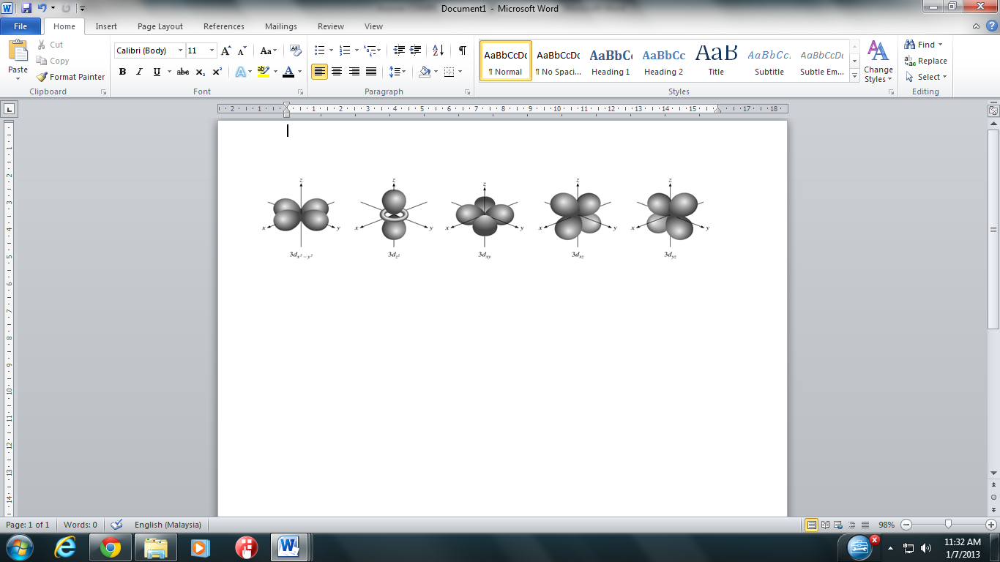 [4 marks]

|  |  |  |
| --- | --- | --- |
|  |  | 1. Give a possible value of principal quantum number, *n*, angular momentum quantum number, *l* and magnetic quantum number, *m* for 2*s* and 3*d* orbitals.   ***2s: n = 2, l = 0, m = 0***  ***3d: n = 3, l = 2, m = –2 @ – 1 @ 0 @ +1 @ +2***  [4 marks] |

**TK015 2011/2012**

|  |  |  |
| --- | --- | --- |
| 5 | a) | ***Z3-*** ion has 33 protons and neutrons.   1. Determine the number of electrons and nucleon number of ***Z3-***ion.   **Number of electrons = 36**  **Nucleon number = 75**   1. Write the symbol of ***Z*** atom.   [3 marks] |
|  |  |  |
|  | b) | 2-methylpropane reacts with chlorine gas at room temperature in the presence  of ultraviolet light to form 2-chloro-2-methylpropane. The balanced equation of the reaction is  *uv*  C4H10 + Cl2 → C4H9Cl + HCl  [Volume of 1 mole of chlorine gas at room temperature is 24.0 L]  If 4.06 g of C4H10 is mixed with 1200 mL of Cl2   1. which of the compound is a limiting reactant?     ***From the equation,***  ***1 mol of C4H10***  ***1 mol Cl2***  ***0.05 mol of Cl2 gas***  ***0.05 mol of C4H10***  ***So, Cl2 is limiting reactant***   1. determine the mass of excess reactant.   ***n C4H10 excess = ngiven - nreact***  ***= ( 0.07 – 0.05 ) mol***  ***= 0.02 mol***  ***Mass excess C4H10 = 0.02 mol x 58 g mol-1***  ***= 1.16 g***   1. how many grams of C4H9Cl is produced?   ***1 mol of Cl2 gas***  ***1 mol of C4H9Cl***  ***0.05 mol of Cl2 gas***  ***0.05 mol of C4H9Cl***  ***Mass C4H9Cl = 0.05 mol x 92.5 g mol-1***  ***= 4.625 g***  [7 marks] |
|  |  |  |
| 6. | a) | Balance the following equation:  IO3- + Mn2+ → I- + MnO2 *(acidic)*  ***Oxidation: Mn2+ → MnO2***  ***Reduction: IO3 – → I–***  ***Balance O by adding H2O***  ***Oxidation: Mn2+ + 2H2O→ MnO2***  ***Reduction: IO3 – → I– + 3H2O***  ***Balance H by adding H+***  ***Balance Oxidation: Mn2+ + 2H2O → MnO2 + 4H+***  ***Reduction: IO3 – + 6H+ → I– + 3H2O***  ***Balance charge***  ***Oxidation: Mn2+ + 2H2O → MnO2 + 4H+ + 2e***  ***Reduction: IO3 – + 6H+ + 6e → I– + 3H2O***  ***Balance equation***  ***Oxidation: 3Mn2+ + 6H2O → 3MnO2 + 12H+ + 6e***  ***Reduction: IO3 – + 6H+ + 6e → I– + 3H2O***  ***Combine equations***  ***3Mn2+ + 6H2O + IO3 – + 6H+ → 3MnO2 + 12H+ + I– + 3H2O***  ***Simplify & Calculate the total charge***  ***3Mn2+ + 3H2O + IO3 – → 3MnO2 + 6H+ + I–***  [4 marks] |
|  | b) | 70 mL of a saturated NaOH solution having 65 % NaOH by weight and a density of 1.79 g mL-1 is diluted to prepare a 0.20 M NaOH solution. Determine the initial concentration of the 70 mL of saturated NaOH solution and the final volume of the solution to prepare 0.20 M NaOH solution.  ***Volume of NaOH***    **@**    ***To prepare 0.2 M solution:***    [ 6 marks] |
| 7. | a) | When an electron makes a transition from a higher energy level to a lower one, a photon with frequency 9.7 x 1015 s-1 is emitted. Calculate   1. wavelength of the photon.   ***λ = c***  ***ν***  ***λ = 3 x 108 ms-1***  ***9.7 x 1015 s-1***  ***= 3.09 x 10-8 m or 30.9 nm***   1. energy emitted by one mole of electrons for the above transition.   ***ΔE = hν***  ***= 6.6256 x 10-34 Js x 9.7 x 1015 s-1***  ***= 6.43 x 10-18 J***  ***Energy emitted by 1 mol of electrons***  ***= 6.43 x 10-18 x 6.02 x 1023***  ***= 3870860 J mol-1 @ 3870.86 kJ mol-1***  [5 marks] |
|  |  |  |
|  | b) | One of the lines in the atomic hydrogen line emission spectrum which in the visible region has a wavelength of 410.2 nm.   1. What is meant by line spectrum?   ***Line spectrum is a spectrum consists of discontinuous or discrete lines***  ***produced by electons as they fall to a lower energy level.***   1. Give the name for this series of line spectrum.   ***Balmer series***   1. Determine the transition of the electron involved.   **= RH**    **n2 2 = 35.7143**  **n2 = 5.976**  ≈ **6**  [5 marks] |
|  |  |  |
| 8. | a) | State **one** success and **one** failure of the Bohr’s atomic model in terms of the line emission spectrum. Define what is an orbital?  ***Bohr was able to account for the atomic spectra of hydrogen and other single electron ions. However the theory was not able to explain atoms or ions with more than one electron.***  ***Orbital : The region/area/3 dimensional space around the nucleus where the probability of finding the electron is very high.***  [3 marks] |
|  |  |  |
|  | b) | Write the electronic configuration of chromium. Give reasons why it disobey the normal Aufbau principle.  ***24Cr: 1s2 2s2 2p6 3s2 3p6 3d5 4s1 @ 1s2 2s2 2p6 3s2 3p6 4s1 3d5***  ***Reasons :***  ***To achieve stability of a half-filled orbital arrangement, one electron from the 4s orbital must occupy one of the 3d orbitals.***  [3 marks] |
|  |  |  |
|  | c) | An element is known to have 16 protons. Draw all the orbital shapes with the correct axes for the outermost shell electrons of the element. |

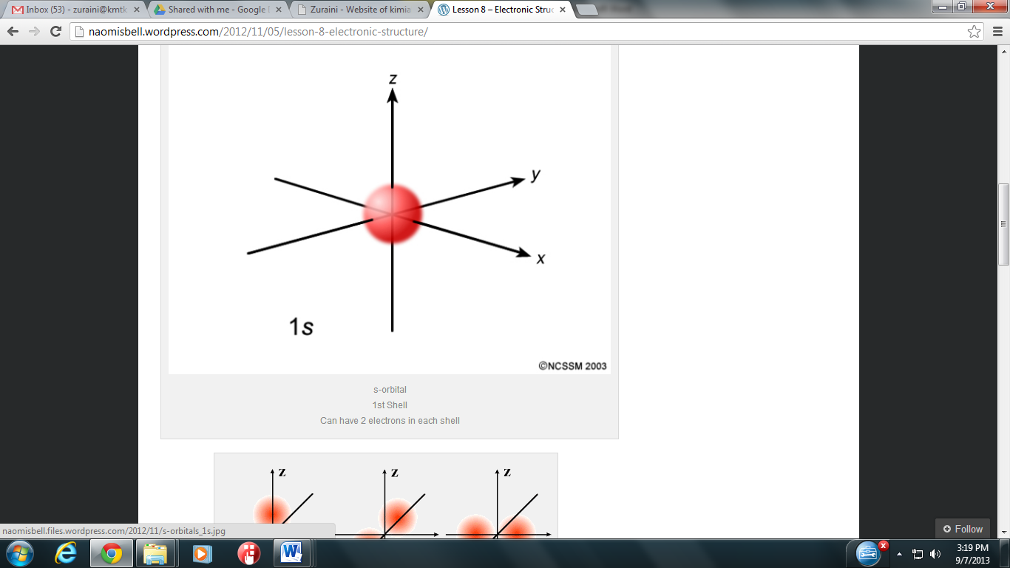

*3s*





[2 marks]

|  |  |  |
| --- | --- | --- |
|  | d) | Write the electronic configuration in the ground state for Ti+. Give a set of quantum numbers for the electrons at the highest energy orbital for Ti+.  [Proton number for Ti is 22]  ***Ti+ : 1s2 2s2 2p6 3s2 3p6 4s1 3d2***  ***(4, 0, 0, +1/2) @ (4, 0, 0, -1/2)***  [2 marks] |

**TK015 2010/2011**

|  |  |  |
| --- | --- | --- |
| 9. | a) | Define molecular formula.  ***The molecular formula is the chemical formula which show the actual number of atoms for each elements in a molecule.***  [1 mark] |
|  |  |  |
|  | b) | Combustion of 0.5 g of compound ***X*** produces 0.75 g of carbon dioxide and 0.205 g of water. If the compound ***X*** has a relative molecular mass of 176.12 and it contains of carbon, hydrogen and oxygen, determine   1. mass of carbon, hydrogen and oxygen in compound ***X***.   ***44.0 g of CO2 contains 12.0 g of carbon atom***  ***0.75 g CO2 contains (12/44 x 0.75 g) = 0.2045 g of C***  ***18.0 g of H2O contains 2.0 g of hydrogen***  ***0.205 g H­2O contains H2O contains (2/18 x 0.205 g) = 0.0228 g of H***  ***Mass of oxygen atom***  ***mass of sample – ( mass of C atom + mass of H )***  ***[0.50 – ( 0.2045 + 0.0228)] g***  ***0.2727 g of O***  [3 marks]   1. empirical formula of ***X***. |

|  |  |  |  |
| --- | --- | --- | --- |
| ***Elements*** | ***C*** | ***H*** | ***O*** |
| ***Mass (g)*** | ***0.2045*** | ***0.0228*** | ***0.2727*** |
| ***Number of moles*** | ***0.2045/12***  ***= 0.0170*** | ***0.0228/1***  ***=0.0228*** | ***0.2727/16***  ***= 0.0170*** |
| ***Mole ratio*** | ***0.0170/0.0170***  ***= 1*** | ***0.0228/0.0170***  ***= 1.34*** | ***0.0170/0.0170***  ***= 1*** |
| ***Simplest mole ratio*** | ***1 x 3 = 3*** | ***1.34 x 3 = 4*** | ***1 x 3 = 3*** |
| ***Empirical Formula*** | ***C3H4O3*** | | |

[4 marks]

|  |  |  |
| --- | --- | --- |
|  |  | 1. molecular formula of ***X***.   ***[C3H4O3] n = 176.12***  ***[3(12) + 4(1) + 3(16)] n = 176.12***  ***n = 2***    ***the molecular formula of X is C6H8O6***  [2 marks] |
|  |  |  |
| 10 | a) | **TABLE 1** listed some characteristics of the elements Sr and ***Q***. Determine the corresponding values for **A**, **B**, **C** and **D** as well as the symbol for ***Q*** ion in the table below. |

**TABLE 1**

|  |  |  |  |  |  |
| --- | --- | --- | --- | --- | --- |
| Element | Net Charge | Nucleon Number | Proton Number | Electron Number | Neutron Number |
| Sr | +2 | 90 | 38 | **A** | **B** |
| ***Q*** | **D** | 82 | **C** | 36 | 47 |

|  |  |  |  |
| --- | --- | --- | --- |
|  |  | *A*  *B*  *C*  *D* | ***= 36***  ***= 52***  ***= 35***  ***= – 1***  [ 5 marks] |
|  |  |  |  |
|  | b) | 25.0 g sample of copper was added into a 25.0 L of solution containing 13.6 g Ag+ per litre. The reaction occurred was as follows:  Cu + 2 Ag+ → Cu2+ + 2 Ag  Was the added copper enough to react completely with all the Ag+ in the solution? Explain your answer.    ***From equation;***  ***1 mole Cu will react with 2 mole Ag+***  ***If 0.3931 mole Cu = 2 x 0.3931***  ***= 0.7862 mole Ag+***  ***Cu not enough to react completely with Ag+***  ***Or***  ***Ag+ will be excess reactant, Cu is limiting reactant***  [5 marks] | |
| 11. | a) | Figure below shows a part of the line spectrum of hydrogen atom in the visible light region. | |

red

indigo

blue

violet

Frequency increases

|  |  |  |
| --- | --- | --- |
|  |  | 1. Show the electron transitions with a labeled diagram which produce the above coloured lines. |

*n* = 1

*n = 2*

*n* = 3

*n* = 4

*n* = 5

*n* = 6

*n* = ∞

***Energy***

***red***

***blue***

***indigo***

***violet***

[4 marks]

|  |  |  |
| --- | --- | --- |
|  |  | 1. State how the indigo line is formed?   *When electron at excited state* ***n = 5 drops to ground state n = 2.***  [1 mark]   1. What is the line with the second longest wavelength, λ? What is the line with the second longest wavelength, λ?   ***Blue line***  [1 mark] |
|  |  |  |
|  | b) | Calculate the energy and wavelength when an electron makes a transition from the third energy level to the first energy level of a hydrogen atom.  [4 marks] |
| 12 | a) | State the shapes of *s*  and *p* orbitals. How are these orbitals related to the quantum number *l* ?  ***s = spherical l = 0 for s orbital***  ***p = dumb – bell l = 1 for p orbital***  [2 marks] |
|  |  |  |
|  | b) | Draw orbital diagram for the highest energy orbital of an atom with the electronic configuration ***1s2 2s2 2p6 3s2 3p6 4s2 3d7***. Name one of those orbitals and draw it shape with the correct axes. |

***4s***

***4s***

[3 marks]

|  |  |  |
| --- | --- | --- |
|  | c) | Copper is the ninth element in the first row of the *d*-block of the Periodic Table.   1. Write the electronic configuration of copper according to the Aufbau principle and the actual configuration as determined by experiments.   ***According to Aufbau principle:***  ***29Cu = 1s2 2s2 2p6 3s2 3p6 4s2 3d9***  ***According to experiment:***  ***29Cu = 1s2 2s2 2p6 3s2 3p6 4s1 3d10***  [2 marks]   1. Give the reason for the anomaly.   ***The reason for anomaly - completely filled 3d orbitals are more stable compared to partially filled 3d orbitals.***  [1 mark]   1. Name another transition element which also shows anomaly and write its electronic configuration.   **24Cr / Chromium**  **24Cr =** **1*s2* 2*s2*2*p6* 3*s2* 3*p6* 4*s1*3*d5* @ [Ar] 4*s1*3*d5***  [2 marks] |

**TS017 2009/2010**

|  |  |  |
| --- | --- | --- |
| 13. | a) | Define isotope.  ***Two or more atoms of the same element having the same proton number but with different nucleon numbers @ number of neutrons.***  Write down the isotope notation of oxygen with proton number of 8 and nucleon number of 16.  [2 marks] |
|  |  |  |
|  | b) | The density of 10 % by mass of NaOH solution is 1.06 g mL-1. Calculate the molality of the solution.  ***Assume volume of solution 1000mL***      ***= 2.778 molal***  **Or**  ***= 2.778 molal***  [4 marks] |
|  |  |  |
|  | c) | An aqueous solution of MgSO4 is added to an aqueous solution of BaCl2 to form BaSO4 and MgCl2. If 1.75 g of MgSO4 and 2.75 g of BaCl2 are used,   1. determine the limiting reactant.   ***MgSO4 + BaCl2 → BaSO4 + MgCl2***   1. calculate the mass of BaSO4 produced after the reactant has completed.   ***BaSO4***    [4 marks] |
|  |  |  |
| 14. | a) | The transition of an electron in hydrogen atom releases 4.58 x 10 -19 J energy which produces a line in the visible light region.   1. Calculate the wavelength in nm of the line produced.      1. The hydrogen atom emission spectrum is in the form of a line spectrum. Explain your answer.   ***When an excited electron falls to a lower energy level, the energy given off is quantized (photon).***  ***The emission spectrum correspond to the specific frequency or wavelength.***  [5 marks] |
|  |  |  |
|  | b) | The proton number of element ***T*** is 20.   1. Write the electronic configuration of element ***T***.   ***1s2 2s2 2p6 3s2 3p6 4s2***   1. Predict the stable oxidation number of element ***T***. Explain.   ***Oxidation number = +2***  ***2 electrons are removed to achieve stability of noble gas configuration***   1. Draw the shape of orbital and give a set of quantum numbers for the valence electron |



***4s2***

**(n, m, l, s) (n, m, l, s)**

**(4, 0, 0, +1/2) @ (4, 0, 0, -1/2)**

[5 marks]

**SK017 2008/2009**

|  |  |  |
| --- | --- | --- |
| 15 | b) | The density of an aqueous solution containing 10 % of ethanol, C2H 5OH by mass is 0.984 g mL-1. Calculate  [*Molar mass of C2H5OH = 46.0 g mol-1*]   1. the molality of the solution.   ***Assume that mass of solution = 100% = 100 g***  ***Mass of C2H5OH = 10 g***  ***Thus, mass of solvent, H2O = ( 100 - 10 ) g***  ***= 90 g @ 0.090 kg***  ***Mol of C2H5OH =  = 0.217 mol***  ***Molality* =**  **=**   1. its molarity         ***= 2.14 M***   1. the volume of the solution that contains 0.125 mole of ethanol.   ***0.217 mol of C2H5OH  0.1016 L***  ***0.125 mol of C2H5OH***  ***= 0.0585 L***  ***@***    [4 marks] |
|  |  |  |
|  | a) | Calculate the frequency and wavelength of the third line in the Balmer series of hydrogen spectrum.  **= 1.097 x 107 m -1**  **= 2.304 x 10 6 m-1**  **λ = 4.341 x 10-7 m @ 434 nm**      [5 marks] |
|  |  |  |
|  | b) | Between 4*s*, 5*f* and 2*d* which orbital represents impossible combination of *n* and *l*?  Explain.  ***2d***  ***n = 2, the possible l values = 0 or 1***  ***For 2d orbital; n = 2, l = 2. So, the l value is not allowable***  [2 marks] |
|  |  |  |
|  | c) | Phosphorus is an element in period 3.   1. Write the electronic configuration of phosphorus.   ***1s2 2s2 2p6 3s2 3p3 @ [Ne] 3s2 3p3***  [2 marks]   1. Draw its orbital diagram. |

*1s*

*2s*

*2p*

*3p*

*3s*

|  |  |  |
| --- | --- | --- |
|  |  | 1. How many unpaired electrons does it have?   ***Three***  [1 mark] |

**SK017 2007/2008**

|  |  |  |
| --- | --- | --- |
| 18. |  | A solution made by dissolving 16.0 g of CaCl2 in 64.0 g of water has a density of  1.18 g/mL at 20 °C. Determine   1. the percent by mass of CaCl2.   **w/w % =**  **=**  **= 20%**   1. the molarity of CaCl2 solution.   **Mole of solute =**  **= 0.144 mol**  **Volume of solution =**    **Molarity =**  **Molarity =**  **= 2.12 M**  [ 6 marks] |
|  |  |  |
| 19. | a) | Give the difference between a line spectrum and a continuous spectrum.  **Line spectrum:**  A spectrum that consists of **discrete lines**, each with a **specific wavelength**.  **Continuos spectrum:**  A spectrum that contains **radiation of all wavelengths**.  [2 marks] |
|  |  |  |
|  | b) | The orbitals of the first two principal energy levels of atoms are shown below. |

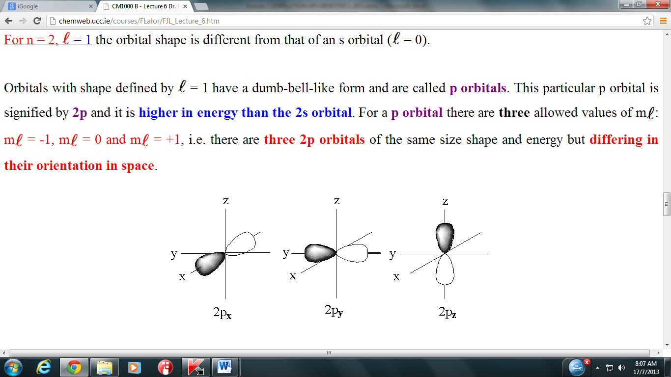 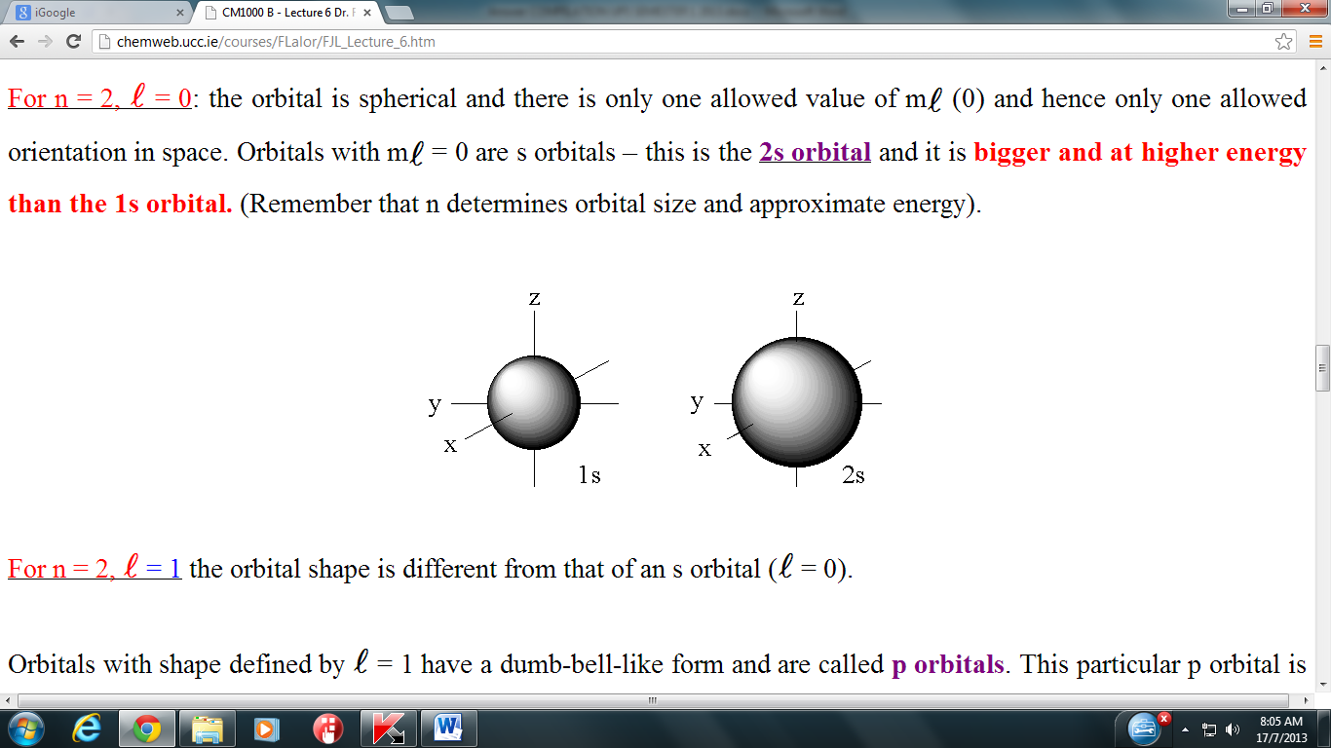 

***A B C***

 

***D E***

|  |  |  |
| --- | --- | --- |
|  |  | In an atom of element ***J***, orbitals ***A***, ***B*** and ***E*** are full of electrons while orbitals ***C*** and ***D*** are half full.   1. State the charge of ***J*** ion. Briefly explain your answer.   *Charge of* ***J*** *ion = -2*  ***J*** *atom will* ***accept*** *another* ***2 electrons*** *to complete its octet.*   1. Write the electronic configuration of ***J***.   ***1s2 2s2 2p4***   1. State the quantum number *n*, *l* and *m* for orbital ***D***. |

|  |  |  |  |
| --- | --- | --- | --- |
| **Quantum number** | ***n*** | ***l*** | ***m*** |
| **Value** | **2** | **1** | **0 or -1 or +1** |

[4 marks]

|  |  |  |
| --- | --- | --- |
|  | c) | An electron of a hydrogen atom is excited to the energy level n = 4 and drops to a lower energy level to form a line in the Balmer series.   1. Calculate the energy of the electron at the energy level n=4.   **E =**    **= - 1.36 x 10-19 J**   1. Determine the wavelength of this transition.     ***@ 486 nm***  [4 marks] |

**SK017 2006/2007**

|  |  |  |
| --- | --- | --- |
| 20. | a) | Determine the number of electrons in germanium ion, .  ***Number of electrons = 30***  [1 mark] |
|  |  |  |
|  | b) | At room temperature, 255 g of copper (I) oxide, Cu2O react with 180 g of copper (I) sulphide, Cu2S according to the equation below:  2 Cu2O + Cu2S  6 Cu + SO2  Determine   1. the limiting reactant.   ***mol of Cu2O =  = 1.783 mol***  ***mol of Cu2S =  = 1.131 mol***  ***From the equation,***  ***2 mol of Cu2O  1 mol Cu2S***  ***1.783 mol of Cu2O  ½ x 1.783 mol Cu2S***  ***= 0.892 mol Cu­2S***    ***Since Cu2S at hand (1.131 mol) exceeds the need (0.892 mol), Cu2S is***  ***the excess reactant. Therefore Cu2O is the limiting reactant.***  [ 3 marks]   1. the mass of the excess reactant remained at the end of the reaction.   ***Mol of excess Cu2S = 1.131 – 0.892 = 0.239 mol***  ***Mass of excess Cu2S = 0.239 mol x [(2 x 63.5) + (32.1)] g mol-1***  ***= 38.1 g***  [*Molar mass of Cu2O = 143.0 g mol-1; Molar mass of Cu2S = 159.1 g mol-1*]  [2 marks] |
|  |  |  |
|  | c) | An aqueous ammonia solution with a density of 0.898 g mL-1 contains 28 % ammonia by mass. Calculate the molarity of the solution.  ***Assume the mass of aqueous ammonia solution = 100 g***  ***Mass of water = 100 g – 28 g = 72 g***  ***Density = Mass / Volume***  ***Volume NH3 solution = 100 g ÷ 0.898 g mL-1***  ***= 111.36 mL @ 111.36 x 10-3 L***  ***Molarity = mol of solute / volume of solution (L)***  ***= 14.8 M***  [4 marks] |
|  |  |  |
| 21. | a) | 1. Calculate the wavelength and frequency of the light that forms the third line of the Brackett series.   ***The third line of Brackett series, n1 = 4 , n2 = 7***  **= RH**  **= 1.097 x 10-7 m-1**  **= 2.166 x 10-6m**  **= c /**  **=**  **= 1.4 x 1014 s-1**  [4 marks]   1. Calculate the energy of an electron at its excited state before it drops to produce the second line of the Balmer series.   **En  =**  **E4 = - 2.18 x 10-18 J**  **= - 1.36 x 10-19 J**  [2 marks] |
|  |  |  |
|  | b) | 1. State the quantum numbers *n, l,* and *m* of the 3*dx2-y2* orbital and draw its shape.   ***n = 3, l =2, m = -2 @ -1 @ 0 @ +1 @ +2*** |

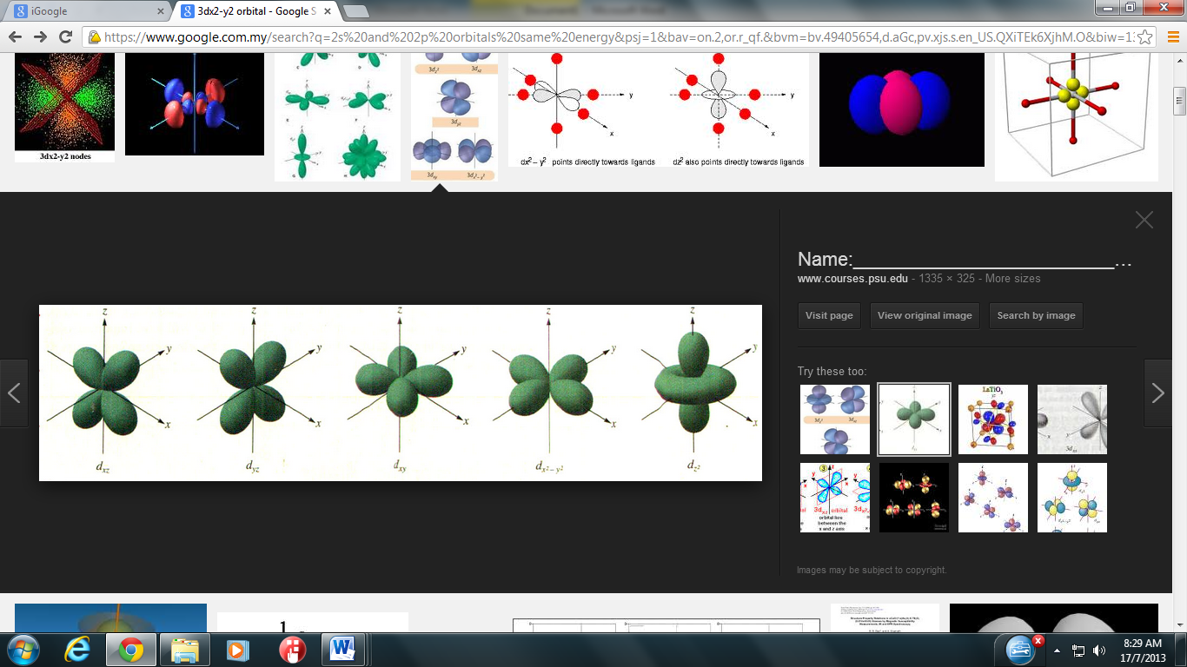

[2 marks]

|  |  |  |
| --- | --- | --- |
|  |  | 1. Write the electronic configurations of Mn and Mn2+.   ***25Mn : 1s2 2s2 2p63s2 3p64s2 3d5  @ 1s2 2s2 2p6 3s2 3p6 3d5 4s2***  ***25Mn2+ : 1s2 2s2 2p6 3s2 3p6 3d5***  [2 marks] |

**SK017 2005/2006**

|  |  |  |
| --- | --- | --- |
| 22. | At a high temperature metal oxide *M*2O3 reacts with hydrogen gas to produce metal M and water. The reaction of 10.64 g sample of *M*2O3 will produce 3.78 g of water. | |
|  | a) | Write a balanced chemical equation for the above reaction.  ***M2O3  + 3 H2 → 2 M + 3 H2O***  [1 mark] |
|  |  |  |
|  | b) | Calculate   1. the relative molecular mass of *M*2O3.   ***n H2O = mass H2O / molar mass H2O***  ***n H2O = 3.87 g/ 18 g mol-1 = 0.21 mol***  ***From balanced equation:***  ***3 mol H2O ≡ 1 mol M2O3***  ***0.21 mol H2O ≡ 0.07 mol M2O3***  ***So, relative molecular mass M2O3 = 10.64 g / 0.07 mol***  ***= 152*** [5 marks]   1. the mass of *M* produced.   ***3 mol H2O ≡ 2 mol M***  ***0.21 mol H2O ≡ 0.14 mol M***  ***So relative atomic mass of M:***  ***2(M) + 3(16) = 152***  ***M = 52***  ***Mass of M = mol of M x molar mass of M***  ***= 0.14 mol x 52 g mol-1***  ***= 7.28 g***  [4 mark] |
|  |  |  |
| 23. | a) | An electron of hydrogen atom is excited to an energy level of n = 7 and falls to a lower energy level to produced Paschen series.   1. State the energy level to which the electron falls.   ***n = 3***   1. Calculate the energy of the electron in the excited state.   **= -2.18 x 10-18 J**  **= - 4.4489 x 10-20 J**  [4 marks] |
|  |  |  |
|  | b) | 1. Define the terms of orbit and orbital.   ***Orbital is a three-dimensional region in space where is high probability of finding an electron.***  ***Orbit is the path @ way for an electron to travel around the nucleus of an atom.***   1. Chromium is an element in *d*-block of the periodic table. Write the electronic configuration of chromium. Explain the anomalous electronic configuration in chromium.   ***Observed :***  ***24Cr =******1s2 2s2 2p6 3s2 3p6 4s2 3d4 @ [Ar] 4s2 3d4***  ***Actual :***  ***24Cr =******1s2 2s2 2p6 3s2 3p6 4s1 3d5 @ [Ar] 4s1 3d5***  ***Atoms are more stable in half-filled 3d orbital. To achieve stability, one electrons from 4s orbital occupies one of the empty 3d orbital in order to have a half-filled orbital arrangement.***   1. Give a set of quantum numbers for an electron in 3*p* orbital |

|  |  |  |  |
| --- | --- | --- | --- |
| n | l | m | s |
| 3 | 1 | -1 | -1/2 |
| 3  @  @ | 1 | +1 | -1/2 |
| 3 | 1 | -1 | +1/2 |
| 3  @  @ | 1 | 0 | +1/2 |
| 3 | 1 | +1 | +1/2 |

[6 marks]

**SK017 2004/2005**

|  |  |  |
| --- | --- | --- |
| 24. | a) | Complete and balance the equation by the ion-electron method.  NO2- + I-  → I2 + NO (*acidic solution*)  ***Oxidation: I– → I2***  ***Reduction: NO2- → NO***  ***Balance other than O & H***  ***Oxidation: 2I– → I2***  ***Reduction: NO2- → NO***  ***Balance O by adding H2O***  ***Oxidation: 2I– → I2***  ***Reduction: NO2- → NO + H2O***  ***Balance H by adding H+***  ***Oxidation: 2I– → I2***  ***Reduction: NO2- + 2H+→ NO + H2O***  ***Balance charge***  ***Oxidation: 2I– → I2 + 2e***  ***Reduction: NO2- + 2H+ + e → NO + H2O***  ***Balance Equation***  ***Oxidation: 2I– → I2 + 2e***  ***Reduction: 2NO2- + 4H+ + 2e → 2NO + 2H2O***  ***Combine & Calculate the total charge***  ***2I– + 2NO2- + 4H+ → I2 + 2NO + 2H2O***  [4 marks] |
|  |  |  |
|  | b) | How many atoms of oxygen are there in 3.28 g of Ce2O3?  [3 marks] |
|  |  |  |
| 25. | Consider ***X*** with the neutron and nucleon number of 16 and 31 respectively. | |
|  | a) | Define the term orbital.  ***A three-dimensional region in space where is high probability of finding an electron.***  [1 mark] |
|  | b) | Write the electronic configuration of ***X***.  ***Number of electron = 31 – 16 = 15***  ***X*** *=* ***1s2 2s2 2p6 3s2 3p3***  [1 mark] |
|  | c) | Where is the ***X*** located in the Periodic Table.  ***X located at group 15 and period 3***  [2 marks] |
|  |  |  |
|  | d) | On the separate set of axes, sketch the shapes of all possible orbitals for all valence electron of ***X***. |
|  | [6 marks] | |
| 26. | A sample of methane (CH4) gas having a volume of 2.8 L at 25 °C and 1.65 atm was mixed with sample of oxygen gas having a volume of 35.0 L at 31 °C and 1.25 atm. The mixture was then ignited to form carbon dioxide and water. | |
|  | a) | Define the term ‘limiting reactant’.  ***The reactant that is completely consumed first and determines the amount of product form.***  [1 mark] |
|  | b) | Write balance chemical equation in the above reaction.  ***CH4  + 2O2 → CO2 + 2H2O***  [1 mark] |
|  | c) | From this reaction, determine the limiting reactant.  ***n CH4 = PV / nRT = (1.65) (2.8) / (0.08206)(298) = 0.189 mol***  ***n O2 = PV / nRT = (1.25) (35.0) / (0.08206)(304) = 1.75 mol***  ***1 mol CH4 requires 2 mol O2 , thus 0.189 mol CH4 requires 0.378 mol O2***  ***Since 1.75 mol O2 available, O2 is in excess, hence the limiting reactant is CH4***  [4 marks] |
|  | d) | Calculate the volume (in mL) of CO2 formed at pressure of 2.50 atm and a temperature of 125 °C.  ***From equation; 1 mol CH4 1 mol CO2***  ***Thus 0.189 mol CH4 = 0.189 mol CO2***  ***PV = nRT***  ***V CO2 = 0.189 x 0.08206 x 398) / 2.5***  ***= 2.47 L***  ***= 2470 mL***  [4 marks] |